**THYROID DISORDER PREDICTION USING CLASSFICATION ALOGORITHMS**

**Introduction:**

**The thyroid is a small gland located below the Adam's apple in your neck.**It releases hormones, *thyroxine* (T4) and *triiodothyronine* (T3), which increase the amount of oxygen your body uses and stimulate your cells to produce new proteins. By controlling the release of these hormones, the thyroid determines the metabolic rate of most of your body's organs.

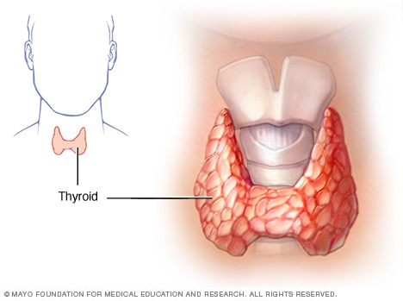The thyroid gland is regulated by *thyroid-stimulating hormone*(TSH), which is made by the pituitary gland in the brain. Normally, when thyroid hormone levels in the body are high, they will "switch off" the production of TSH, which in turn stops the thyroid from making more T4 and T3.

Problems occur when the thyroid gland becomes either underactive (*hypothyroidism*) or overactive (*hyperthyroidism*). Thyroid problems are more common in women than men. Cancer may also develop in the thyroid gland.

**Hypothyroidism (underactive thyroid)** is a condition in which your thyroid gland doesn't produce enough of certain crucial hormones.

**Hyperthyroidism (Overactive thyroid)** may not cause noticeable symptoms in the early stages. Over time, untreated hypothyroidism can cause a number of health problems, such as obesity, joint pain, infertility and heart disease.

**Statistics:**

1. Over 30% of Indians (2015-2016)
2. Thyroid is more prevalent among pregnant women, who are three times more likely to be affected by hypothyroidism than men, especially those in the age group of 46-54 years.
3. Further, people living in the North Indian regions have maximum cases of hypothyroidism as compared to the rest of the country.
4. Compared with coastal cities (eg, Mumbai, Goa, and Chennai), cities located inland (eg, Kolkata, Delhi, Ahmedabad, Bangalore, and Hyderabad) have a higher prevalence (11·7% vs 9·5%)
5. Nearly 32 per cent of Indians are suffering from various kinds of thyroid disorders including thyroid nodules, hyperthyroidism, goiter, thyroiditis and thyroid cancer, says a report.
6. The highest prevalence of hypothyroidism (13·1%) is noted in people aged 46–54 years, with people aged 18–35 years being less aff ected (7·5%).
7. The incidence of thyroid disorders in India is high, with hypothyroidism a particular problem that is not adequately controlled in the country at present.

**SYMPTOMS:**

These are the main symptoms which are suffered by peoples

**Hypothyroidism:**

1. Metabolism gets slow down
2. Lack of energy
3. Obesity
4. Heart disease
5. Joint pain
6. Impaired memory
7. Dry skin

**Hyperthyroidism**

1. Speed up metabolism
2. Difficulty sleeping
3. Muscle weakness
4. Similar to many health problems
5. Sudden weight loss
6. Rapid heart beat
7. Feeling warm

**Risk Factors:**

* Are a woman
* Are older than 60
* Have been treated with radioactive iodine or anti-thyroid medications
* Have a family history of thyroid disease
* Have an autoimmune disease, such as type 1 diabetes or celiac disease
* Have been pregnant or delivered a baby within the past six months

**Methodologies**

* Learning mechanisms
* Understand the problem
* Understand about Data
* Pre-processing
* Feature selection
* Normalization
* Model selection
* Model evolution
* Prediction

**State Visualization:**

After visualizing the data which are collected in data.gov.in the line plot is plotted by two categories which is male and female for all states of INDIA. The below plot clearly explains the kerala state was

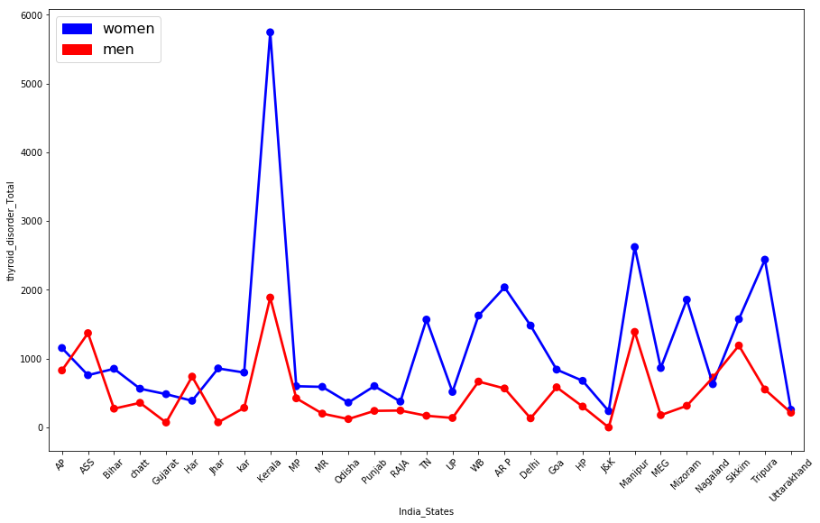 placed as first in gender category the males and females are in high range in kerala. And the minimum range is jammu and Kashmir the people who are lived in J&K they are very chances to get thyroid.

**Model Selection:**

Logistic Regression

Support vector machine(SVM)

Decision Tree

**Actual format for Build a Model**

* Import Packages
* Create Object
* Define Predictor and Target
* Fit the model
* Obtain prediction
* Intercept and Co-efficient
* Estimate model
* Rebuild model (optional)
* Prediction

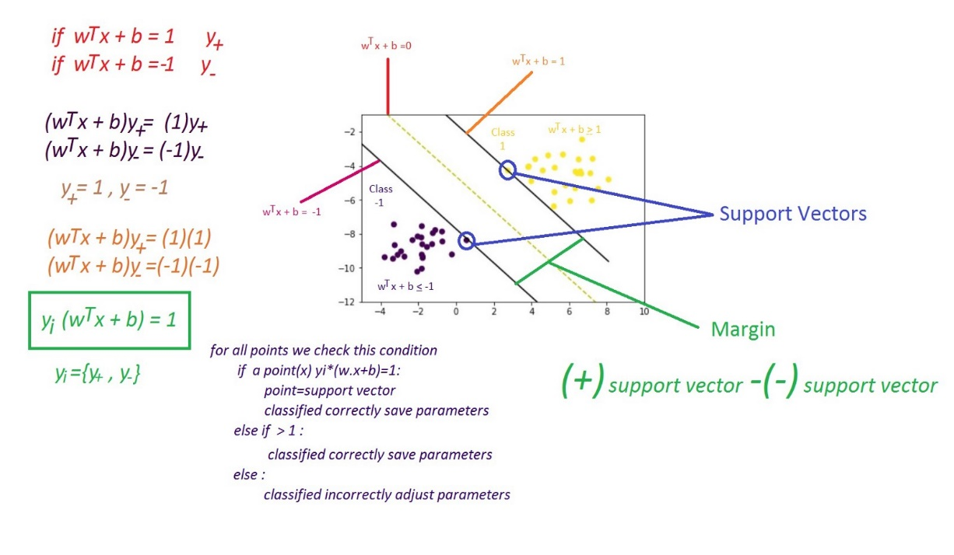**SVM:**

Below one image enough to understand SVM

**Model Evaluation:**

* Most recommended and popular metrices for classification model are

RMSR, R^2 , CM, accuracy score

* Model Evaluation metrics will tell my model accuracy

**Prevention:**

1. Keeping a balanced level
2. Exercise at least 30 min a day
3. Key nutrients selenium, Iodine and zinc
4. Quit smoking
5. Consider Fluoride's Role

**Conclusion:**

* This Machine Learning Model helps to predict patient thyroid disorder stage.
* Zero Rupees within seconds and more accuracy (99%)
* it is important to spread awareness to the people.
* Take the responsibility of future and solve the problem today.

“ Not only Data Scientist is a new trend for building a models with intelligent. It also have responsibilities to solve the problem of people and business.”